CS 255 System Design Document

UML Diagrams

UML Use Case Diagram
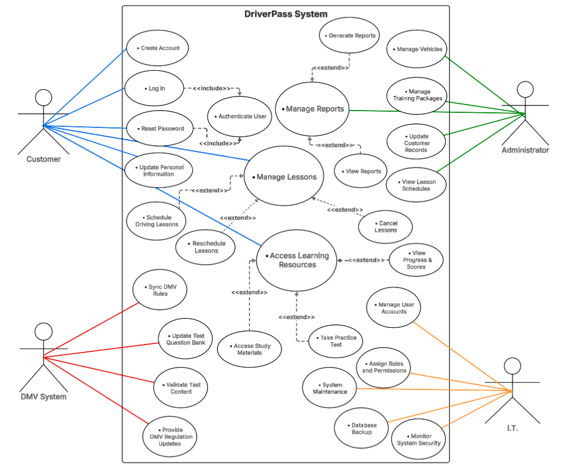

UML Activity Diagrams
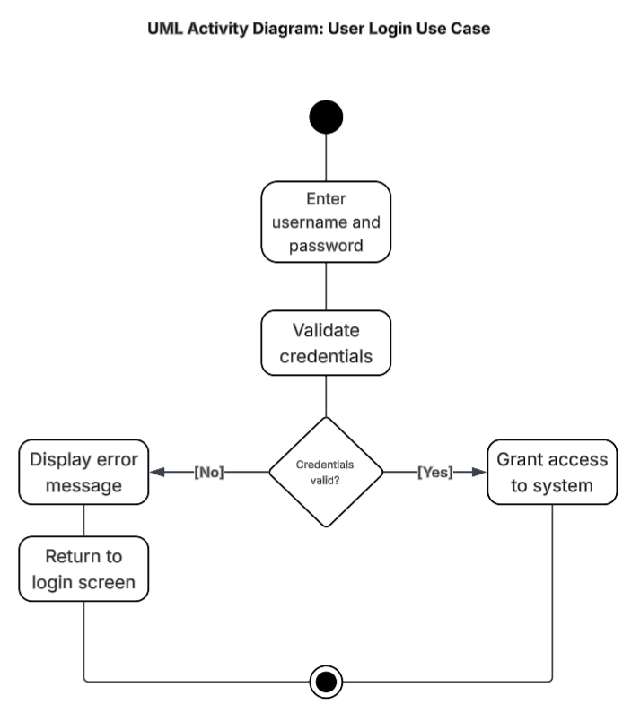

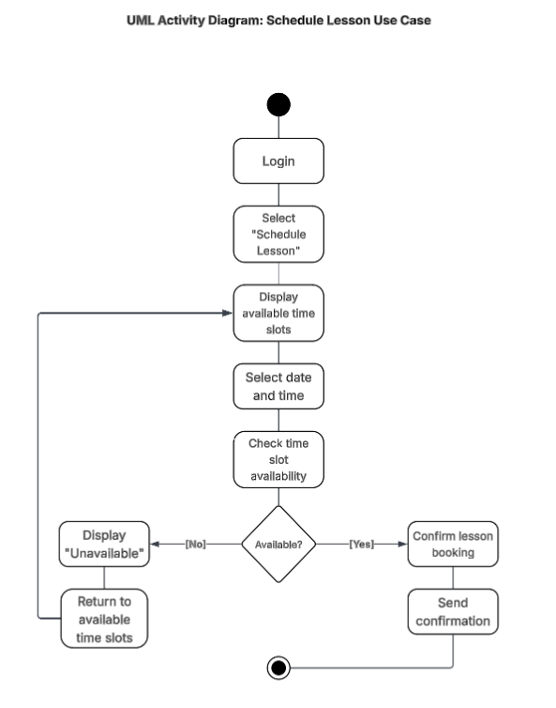

UML Sequence Diagram

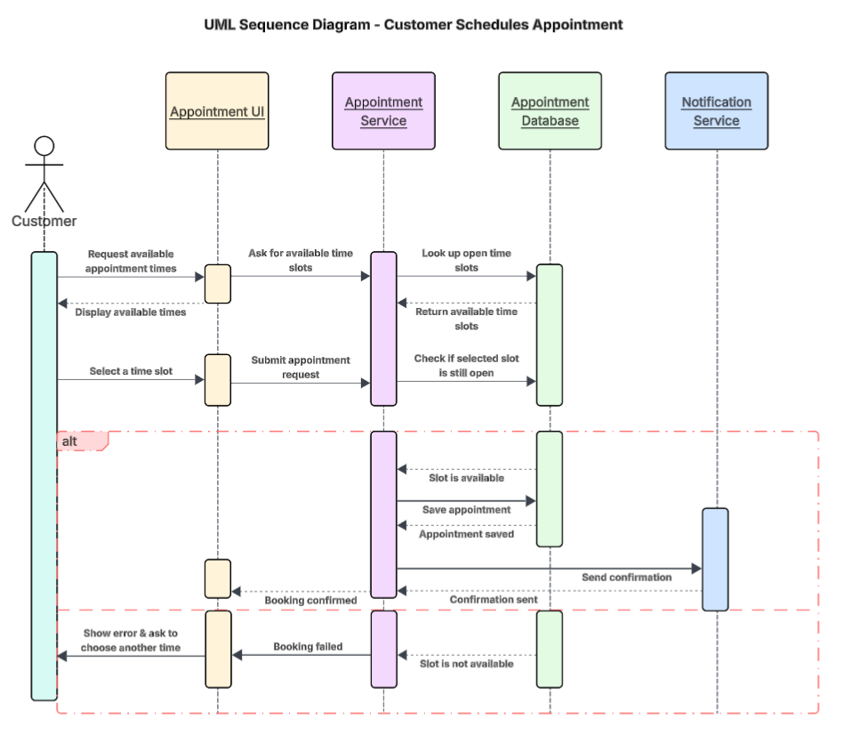

UML Class Diagram

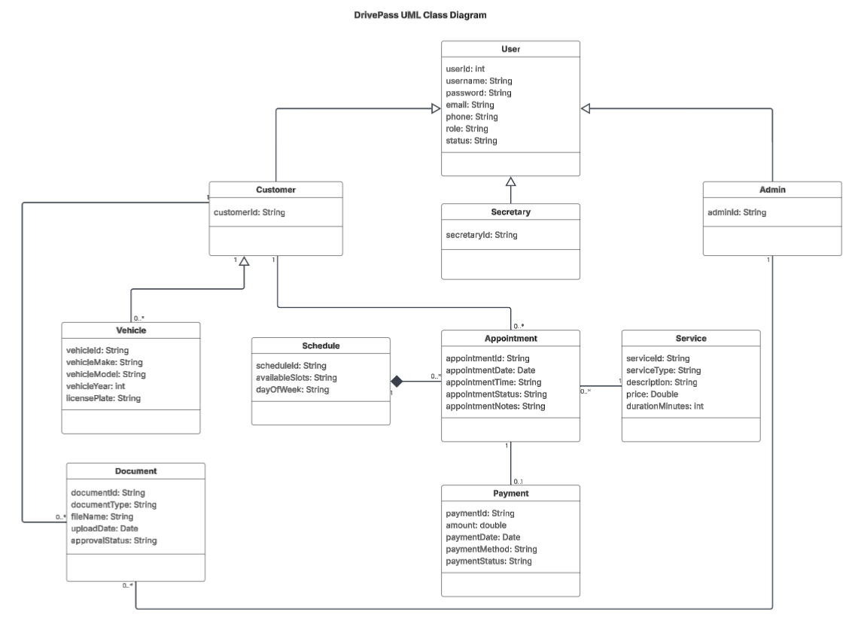

Technical Requirements

The technical requirements for the DriverPass system are based on the functional requirements (user registration, appointment scheduling, document uploads, service management, and payment processing) and the nonfunctional requirements (security, performance, reliability, and usability) identified in Project One.

Hardware Requirements
The system will require a secure server environment to host the web application and database. This may be a cloud-based server or dedicated physical server with adequate processing power, memory, and storage to support multiple users scheduling appointments simultaneously. End users (Customers, Secretaries, and Admins) must have access to a desktop computer, laptop, tablet, or smartphone with internet connectivity.

Software Requirements
DriverPass will operate as a web-based application accessible through modern browsers such as Google Chrome or Microsoft Edge. The system will require a backend framework capable of handling authentication, appointment scheduling, document management, and payment processing. A relational database management system (RDBMS), such as MySQL or PostgreSQL, will store user accounts, vehicles, appointments, services, documents, and payment records. Role-based access control must be implemented to ensure users can only access features appropriate to their role.

Tools and Development Environment
Development of the system may utilize an integrated development environment (IDE) such as Eclipse or Visual Studio Code. Lucidchart was used to create UML diagrams to model system structure and behavior. Version control tools such as Git may be used to manage source code and support collaborative development.

Infrastructure and Security Requirements
To meet nonfunctional security requirements, the system must use HTTPS encryption to protect sensitive data during transmission. Secure storage mechanisms must be implemented for uploaded documents and payment information. The infrastructure should support backup and recovery procedures to ensure data integrity and system reliability. The hosting environment must also support scalability to handle increased appointment volume without performance degradation.
Overall, the technical environment must support secure user authentication, efficient scheduling operations, reliable data storage, and consistent system availability to meet DriverPass’s operational needs. These technical components ensure the system operates securely, efficiently, and reliably while supporting DriverPass’s business goals.

